DISPLAY RULES & REGULATIONS

A. STANDARD BOOTH
DEFINITION
One or more standard units in a straight line

Height

Exhibit fixtures, components and identification signs will be permitted to a maximum height of 8'3" (2.5m).

Depth

All display fixtures over 4'0" (1.22m) in height and placed within 10 lineal feet (3.05m) of an adjoining exhibit, must be confined to that area of the exhibitor’s space which is at least 5'0" (1.52m) from the aisle line.
Intent

Each exhibitor is entitled to a reasonable sightline from the aisle regardless of the size of exhibit. Exhibitors with larger space – 30 lineal feet (9.14m) or more – should also be able to effectively use as much of the total floor space as possible as long as they do not interfere with the rights of others. The limitation on display fixtures over 4'0" (1.22m) and within 10 lineal feet (3.05m) of a neighboring exhibit is intended to accomplish both of these aims.

 |  |  |  |  |  | 8'3" (2.5M)
 |  |  |  |  |  | MAX HT.
 |  |  |  |  |  | 4' (1.22M)
 |  |  | 5' |  |  | 4' (1.22M)
 |  |  | 5' |  |  | MAX HT.
 |  |  | (1.22M)
AISLE

IMPORTANT
Space dimensions shown on floor plan are from center line of booth equipment, such as side rails and/or back drape. Exhibit structures must be constructed to allow sufficient tolerance on each side for this equipment and for utility service at rear of booth.
4’
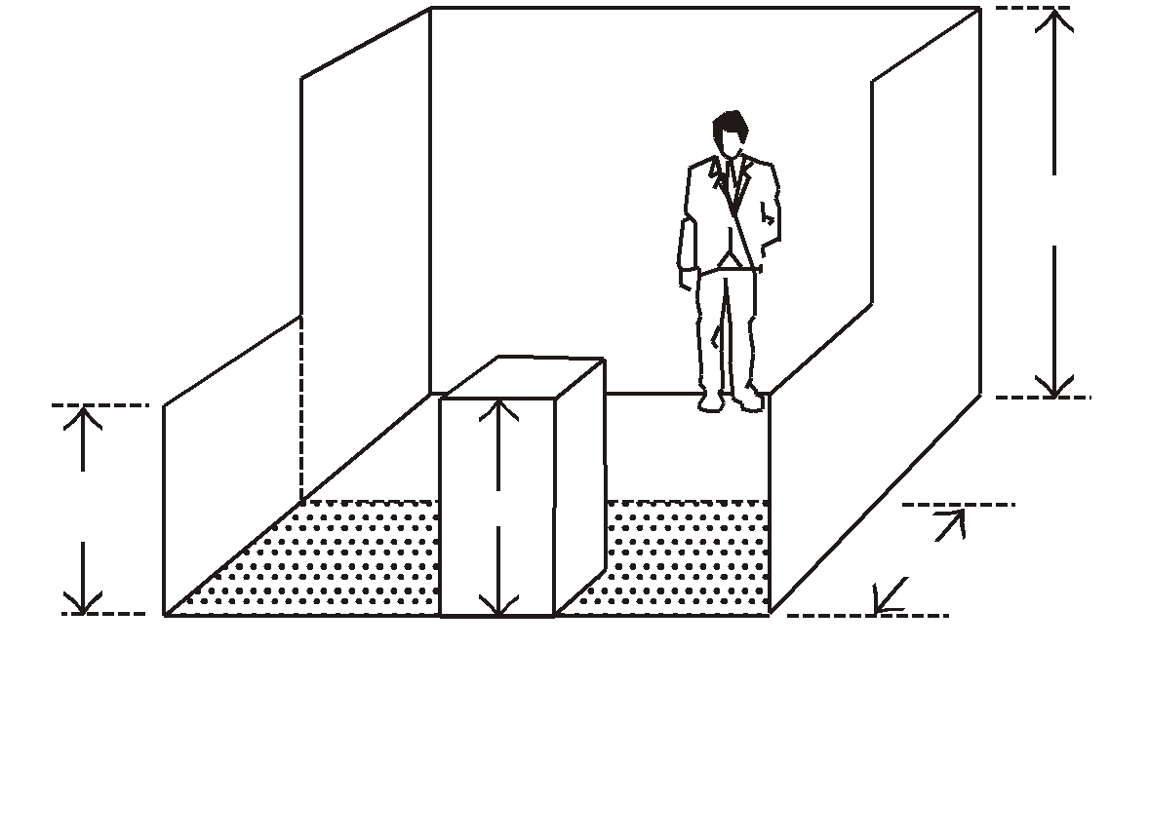

Intent

If a portion of an exhibit booth extends above 8'3" (2.5m) high, the exhibit booth background will detract from the overall impact of the exhibit directly behind that booth regardless of how the rear of the offending exhibit is finished.
8’3” (2.5M)
MAX HT.

4’ (1.22M)
MAX HT.

5’ (1.52M)

DISPLAY FIXTURES OVER4’
(1.22M) HIGH MUST BE CONFINED
TO THAT AREA OF THE BOOTH
THAT IS AT LEAST 5’ (1.52M) FROM
THE AISLE LINE

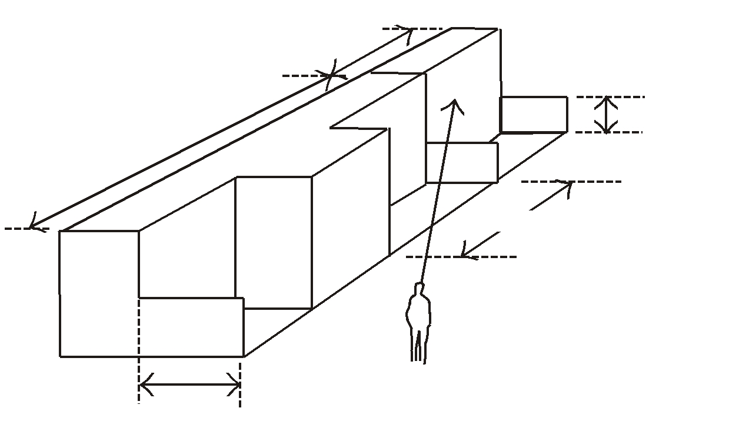
10' (3.05M)
4' (1.22M)
5' (1.52M)
30' (9.4M) BOOTH

B. PERIMETER WALL BOOTH
DEFINITION
Standard booth located on the outer-perimeter wall of the exhibit floor.

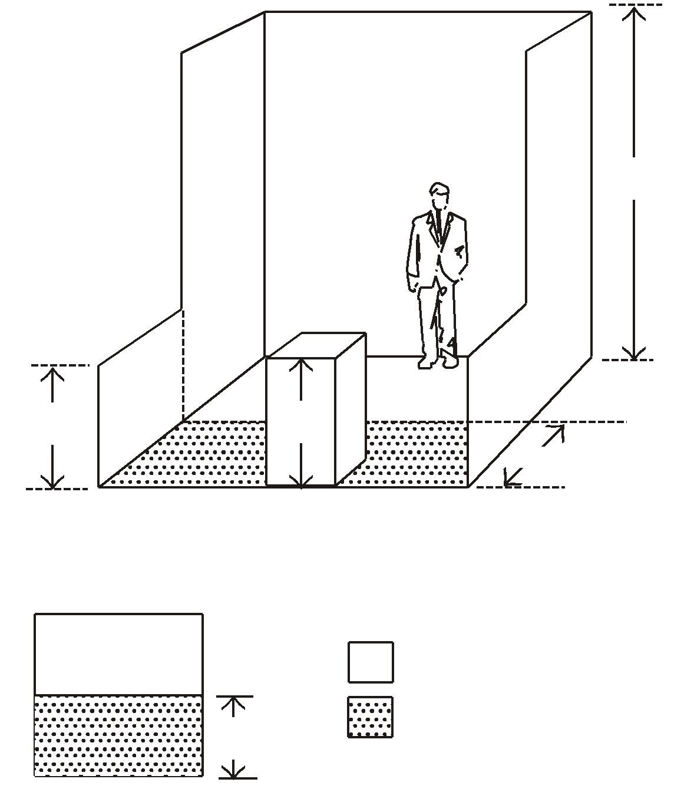
Height

Exhibit fixtures, components and identification signs will be permitted to a maximum height of 12'0" (3.66m) in perimeter-wall booths.

12' (3.66M)
MAX HT.
Intent

Because the outer perimeter booths are not backed up against another exhibitor’s booth, display back walls and materials over 8'3" (2.5m) will not interfere with or distract from any other exhibit booth.

4' (1.22M)
MAX HT.
4’
Depth

All display fixtures over 4'0" (1.22m) in height and placed within 10 lineal feet (3.05m) of an adjoining exhibit, must be confined to that area of the exhibitor’s space which is at least 5'0" (1.52m) from the aisle line.
5' (1.52M)

DISPLAY FIXTURES OVER 4' (1.22M) HIGH MUST BE CONFINED TO THAT AREA OF THE BOOTH THAT IS AT LEAST 5' (1.52M) FROM THE AISLE LINE

12' (3.66M)
MAX HT.
Intent

Each exhibitor is entitled to a reasonable sightline from the aisle regardless of the size of exhibit. Exhibitors with larger space – 30 lineal feet (9.14m) or more – should also be able to effectively use as much of the total floor space as possible as long as they do not interfere with the rights of others. The limitation on display fixtures over 4'0" (1.22m) and within 10 lineal feet (3.05m) of a neighboring exhibit is intended to accomplish both of these aims.

5'
(1.52M)
4' (1.22M)
MAX HT.

AISLE

IMPORTANT
Space dimensions shown on floor plan are from center line of booth equipment, such as side rails and/or back drape. Exhibit structures must be constructed to allow sufficient tolerance on each side for this equipment and for utility service at rear of booth.

Exhibitors considering a perimeter-wall booth in order to take advantage of the extra height permitted should design their exhibit so that it can be used either at the 8'0" (2.44m) height or the 12'0" (3.66m) height, so that it can be used in all future shows even if a perimeter-wall space is not available.

C. PENINSULA BOOTH
DEFINITION
Exhibit with one or more display levels in four or more standard units back to back with an aisle on three sides.

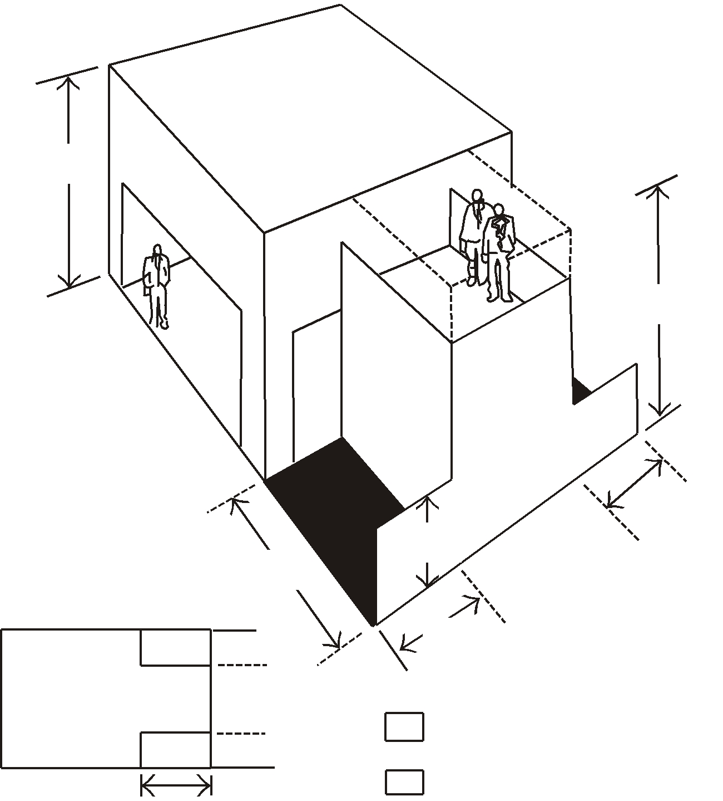
Height
Exhibit features, components and identification signs will be permitted to a maximum height of 16’0” (4.88m), provided written approval is received from exposition management at least 60 days prior to the show.

10'
(3.05M)
Intent

When an exhibit in a peninsula booth configuration exceeds 8'3" (2.5m), it does not interfere with other exhibitors because it does not back up against another exhibitor’s back wall. The extra height is often needed to permit the open walk-through approach normally used in this type of location. The 16'0" (4.88m) height limitation has been set to avoid undue competition between exhibitors to see who can go the highest or be seen the farthest with each negating the others’ efforts. Also, the 16'0" (4.88m) high exhibit will fit into almost any exposition center, thus permitting each exhibitor to get maximum use of his or her exhibit.

16’ (4.88M)
MAX HT.

AISLE
FINISHED
WALL
NO COPY

5’
(1.52M)
4’ (1.22M)
MAX
MUST BE 10’
(3.05M)

AISLE
Depth

All display fixtures over 4'0" (1.22m) in height and placed within 10 lineal feet (3.05m) of a neighboring exhibit, must be confined to that area of the booth that is at least 5'0" (1.52m) from the aisle line to avoid blocking the sightline from the aisle to the adjoining booth.
Intent

Exhibitors adjoining peninsula exhibits are entitled to the same reasonable sightline from the aisle as they would expect if they were adjacent to an exhibitor with a standard booth.
5’
(1.52M)
5’
(1.52M)
NEIGHBORING EXHIBITS

AISLE

4' (1.22M) MAX HT.
5’
(1.52M)
AISLE
16' (4.88M) MAX HT.
10’
(3.05M)

engineer indicating that the structure design is properly engineered for its proposed use, and a signature of an authorized official or the exhibit building company indicating that the structure is built in compliance with the details and specifications set forth on the drawings. Signs must also be posted indicating the maximum number of people the structure will accommodate.
IMPORTANT

Peninsula booths are normally “faced” towards the cross aisle. Any portion of the exhibit bordering another exhibitor’s booth must have the back side of that portion finished and must not carry identification signs or other copy that would detract from the adjoining exhibit.

Exhibitors are cautioned when installing a display with a ceiling or second level to check with the local fire department to insure that their display meets with the necessary fire safety precautions involving smoke alarms, fire extinguishers, sprinkler systems, etc.

Structural Integrity

All multi-story exhibits, regardless of whether people will occupy the upper area or not, and all exhibit fixtures and components 16'0" (4.88m) in height must have drawings available for inspection by exposition management, the installation and dismantling contractor, the exhibitor and governmental authority during the time the exhibit is being erected, exhibited and dismantled at the show site that include a signature or stamp of a reviewing structural
Intent

Exhibitors in the vicinity of island exhibits are entitled to the same reasonable safety precautions they would expect if they were adjacent to a standard booth.


PENINSULA BOOTHS MAY NOT HAVE SOLID BACKWALLS

D. ISLAND BOOTH
DEFINITION
Exhibit with one or more display levels in four or more standard
Units with aisles on all four sides.

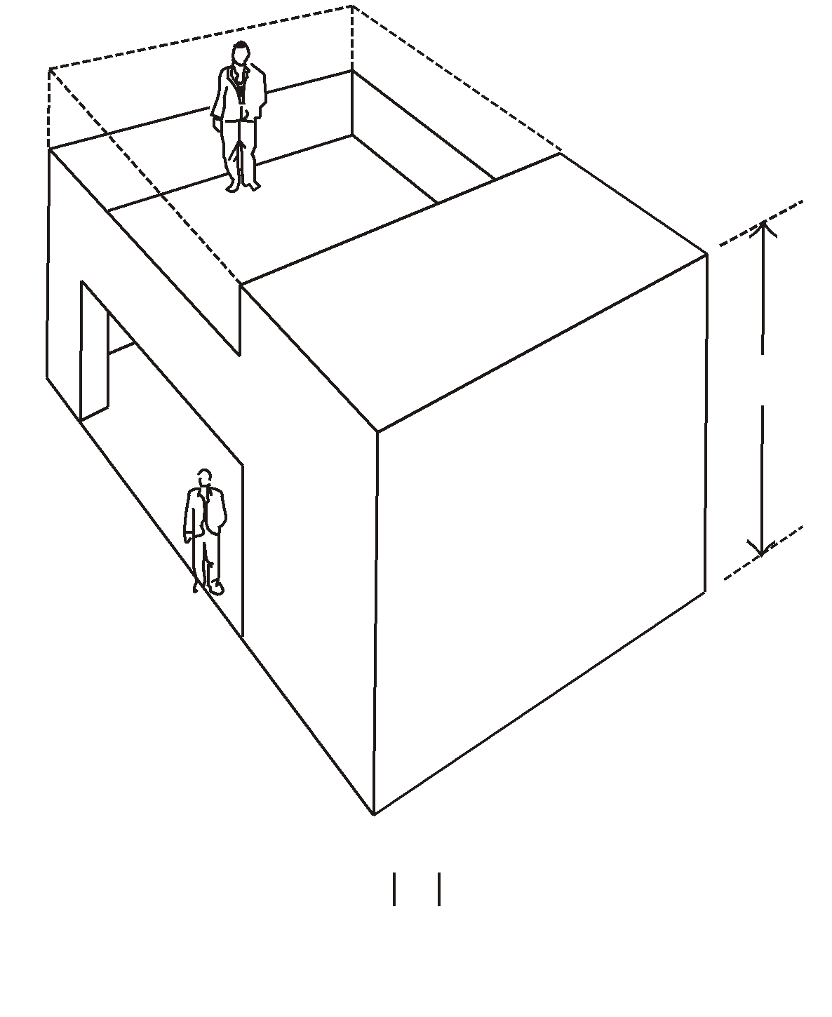
Height

Exhibit fixtures, components and identification signs will be permitted to a maximum height of 16'0" (4.88m), provided written approval is received from exposition management at least 60 days prior to the show.

AISLE
AISLE
16' (4.88M)
MAX HT.

Intent

When an island booth exceeds 8'3" (2.5m), it does not interfere with other exhibitors because it obviously does not back up against another exhibitor’s back wall. The extra height is often required in an island booth exhibit to permit the open walk-through approach normally used in this type of location. The 16'0" (4.88m) maximum height limitation has been set to avoid undue competition between exhibitors to see who can go the highest or be seen the farthest with each negating the other’s efforts. Also, the 16'0" (4.88m) high exhibit will fit into most exposition centres, thus permitting each exhibitor to get the maximum use of his or her exhibit.
AISLE

AISLE

16' (4.88M) MAX HT.

Depth
Because an island booth is automatically separated by the width of an aisle from all neighboring exhibits, full use of the floor plan is permitted.

IMPORTANT
Exhibitors are cautioned when installing a display with a ceiling or second level to check with the local fire department to insure that their display meets with the necessary fire safety precautions involving smoke alarms, fire extinguishers, sprinkler systems, etc.
Structural Integrity

All multi-story exhibits, regardless of whether people will occupy the upper area or not, and all exhibit fixtures and components 16'0" (4.88m) in height must have drawings available for inspection by exposition management, the installation and dismantling contractor, the exhibitor and governmental authority during the time the exhibit is being erected, exhibited and dismantled at the show site that include a signature or stamp of a reviewing structural engineer indicating that the structure design is properly engineered for its proposed use, and a signature of an authorized official of the exhibit building company indicating that the structure is built in compliance with the details and specifications set forth on the drawings Signs must also be posted indicating the maximum number of people the structure will accommodate.
Intent

Exhibitors in the vicinity of island exhibits are entitled to the same reasonable safety precautions they would expect if they were adjacent to a standard booth.

E. CANOPIES & CEILINGS
DEFINITION
An exhibit component supported over an exhibitor’s
space for decorative purposes only.

Height

Canopies, false ceilings and umbrellas will be permitted to a height that corresponds to the height regulation for the appropriate exhibit configuration of which they are a part. For example, canopies will not exceed 8'3" (2.5m) in height in a standard booth configuration. Furthermore, the canopy or false ceiling will not exceed 1'0" (30cm) in depth and cannot be used for identification or display purposes.

MAXIMUM 12” (30CM) DEPTH
FPR CANOPIES OR FALSE CEILINGS
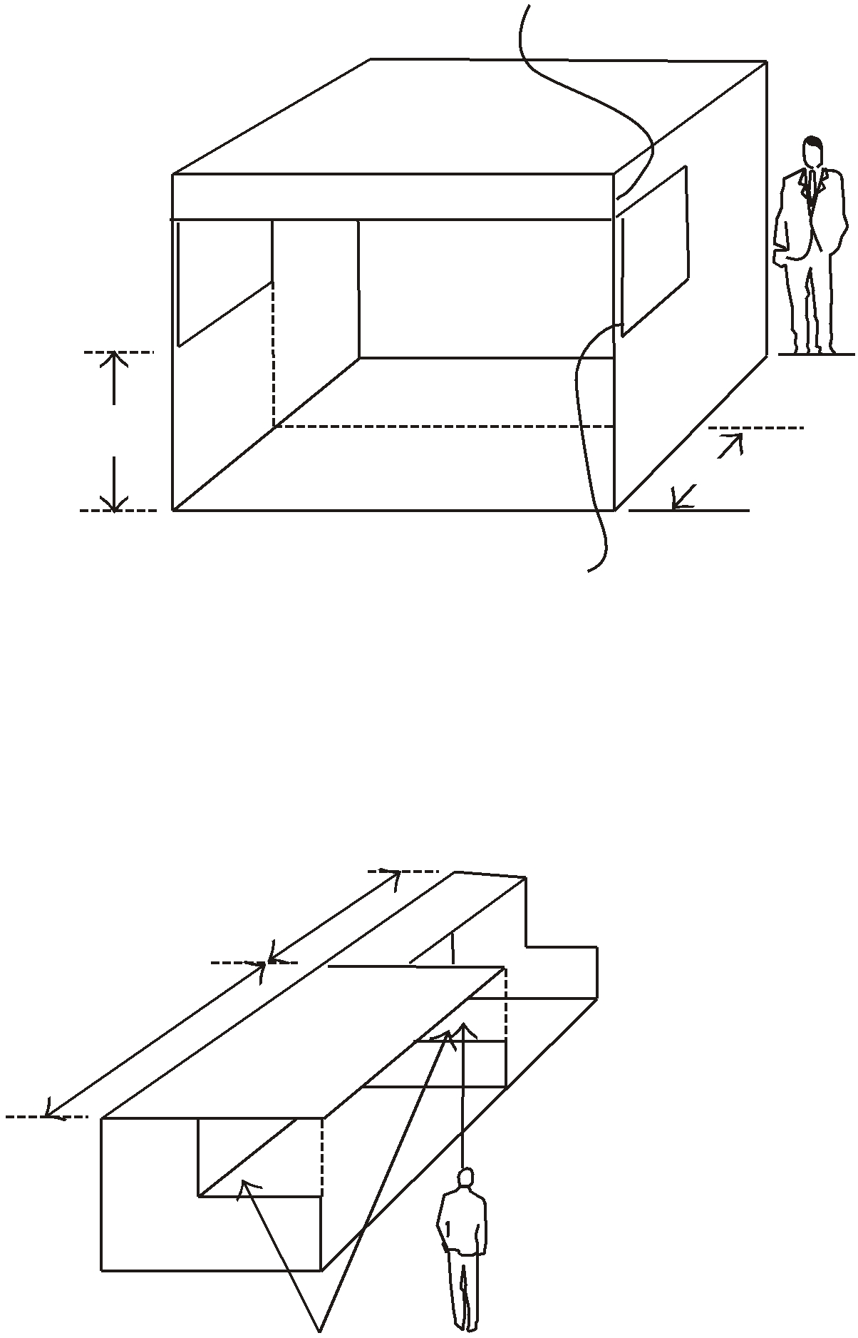

CANOPY

Intent

Exhibitors requiring canopies or false ceilings to create the desired exhibit environment within their booth space should be allowed to do so as long as the canopy and its support structure does not violate the intent of the height or depth regulation.
OPEN
OPEN

4' (1.22M)
MAX HT.
5' (1.52M)

Depth

Canopies may extent out to the aisle line and up to the booth line on either side of an exhibitor’s space providing that the support structure will not exceed 3" (7.62cm) in width when placed within 10 lineal feet (3.05m) of an adjoining exhibit and not confined to that area of the exhibitor’s space which is at least 5'0" (1.52m) from the aisle line. Furthermore, canopies, false ceilings or umbrellas will not be used for identification or display purposes except as would normally be allowed for any exhibit component within the regulations set forth for the exhibit configuration.
AISLE

MAXIMUM 3” (7.62CM) DIAMETER
SUPPORTS PERMITTED FOR CANOPIES
OR FALSE CEILINGS

10' (3.05M) BOOTH

20' (6.1M) BOOTH
Intent

Exhibitors adjoining exhibits with canopies are entitled to the same reasonable sight line from the aisle as they would expect if they were adjacent to an exhibitor with a standard booth.

OPEN
IMPORTANT

Exhibitors are cautioned when installing a display with a ceiling or second level to check with the local fire department to insure that their display meets with the necessary fire safety precautions involving smoke alarms, fire extinguishers, sprinkler systems, etc.

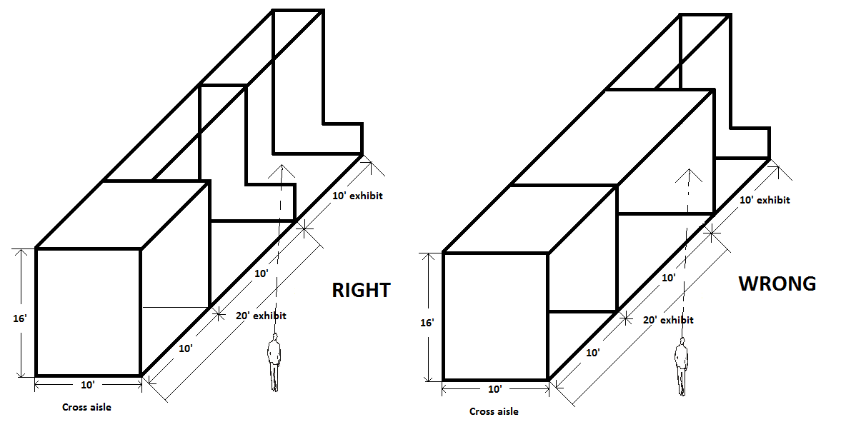
F. Corner & Double Corner
Corner
Definition
A standard exhibit with at least 15’ of main aisle frontage with an adjoining neighboring exhibit on one side and a cross aisle on the other.
Intent
Exhibitors adjoining corner exhibits are entitled to the same reasonable sightline from the aisle as if they were not next to a corner exhibit.

Intent
This type of exhibit must limit the placement of all displays from 14’ to 16’ in height to 5’ from the main aisle and extending 10’ from the common side with the neighboring exhibit to the cross aisle and extending to the main aisles, the 8’ displays are allowed.

Double Corner
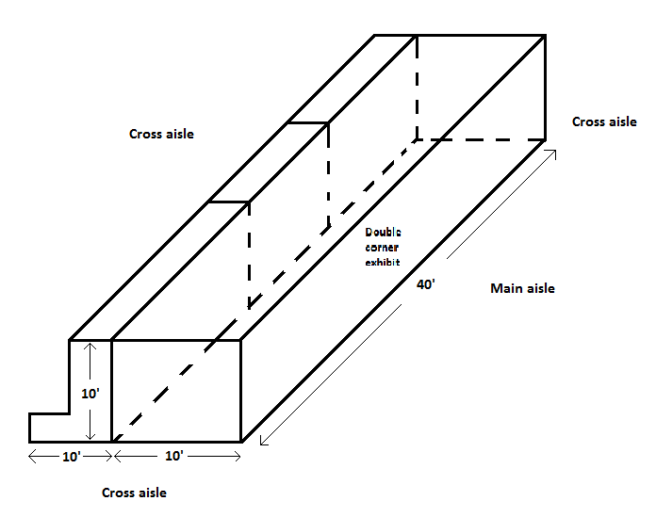
Definition
Double corner exhibits have three open sides, two sides on the cross aisles and one large open side on the main aisle.

Height
All displays and equipment up to 16’ in height are allowed anywhere within the double corner exhibit area because there is no adjacent neighboring exhibit.

G. TOWERS
DEFINITION
A free standing exhibit component separate from the main exhibit
Fixture that is used for identification and display purposes only.

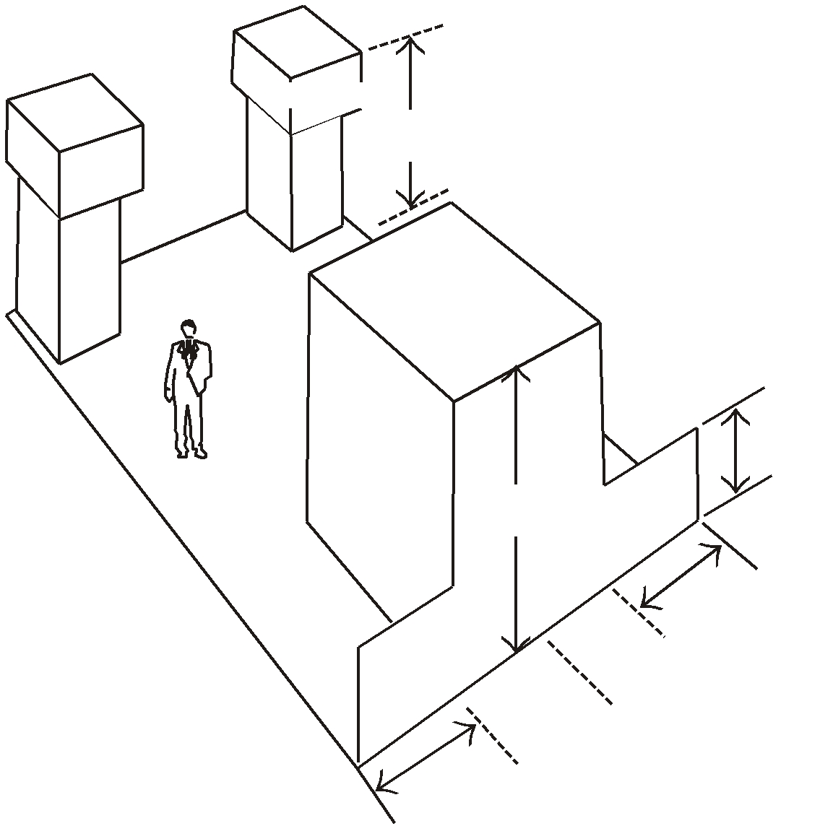

TOWER
16' (4.88M)
MAX HT.
Height/Depth

Towers will be permitted to a height and depth that correspond to the height and depth regulations for the appropriate exhibit configuration of which they are a part. For example, towers that are part of a peninsula exhibit will not exceed 16'0" (4.88m) in height, and will not be placed within 10 lineal feet (3.05m) of a neighboring exhibit unless they are confined to that area of the exhibitor’s space which is at least 5'0" (1.52m) from the aisle line to avoid blocking the sightline from the aisle to the adjoining booth.
TOWER
AISLE

16' (4.88M)
MAX HT.

4'
(1.22M)

Intent

Towers are part of the overall exhibit presentation and, therefore, must be treated as a component of the total exhibit configuration. The maximum height and depth regulations have been set to avoid undue competition between exhibitors to see who can go the highest or be seen the farthest, while also assuring exhibitors who are adjoining exhibits with towers of the same reasonable sightline from the aisle as they would expect if they were adjacent to an exhibitor with a standard booth.
AISLE
AISLE

5'
(1.52M)

NEIGHBORING EXHIBITS

5'
(1.52M)

Structural Integrity

All towers must have drawings available for inspection by exposition management, the installation and dismantling contractor, the exhibitor and governmental authority during the time the tower is being erected, exhibited and dismantled at the show site that include a signature of stamp of a reviewing structural engineer indicating that the structure designed is properly engineered for its proposed use, and a signature of an authorized official of the exhibit building company indicating that the structure is built in compliance with the details and specifications set forth on the drawings.
Intent

Exhibitors adjoining exhibits with towers are entitled to the same reasonable safety precautions they would expect if they were adjacent to a standard booth.

H. HANGING SIGNS
DEFINITION
An exhibit component suspended above an exhibit of four or more standard units back to back
with an aisle on at least three sides for the purpose of displaying graphics or identification

Height

Standard Booth: 8'3" (2.5m)
Perimeter Booth: 12'0" (3.66m)
Peninsula Booth: 16'0" (4.88m)
Island Booth: 16'0" (4.88m)
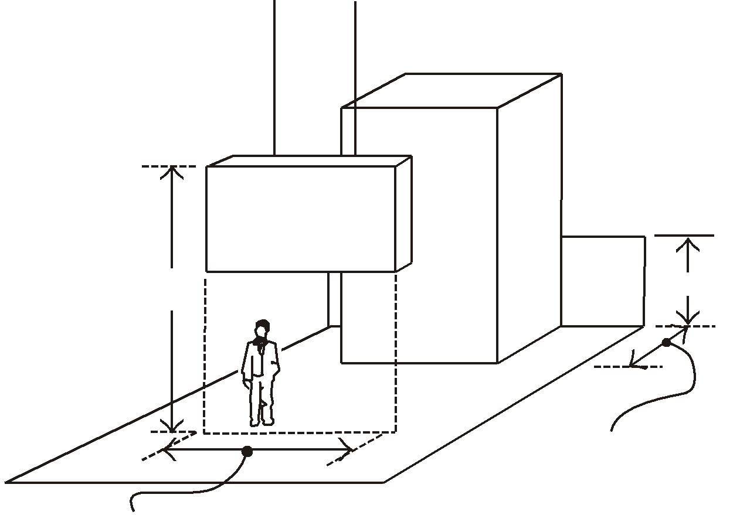

Intent

Hanging signs are part of the overall exhibit presentation and, therefore, must be treated as a component of the total exhibit configuration. All signs, whether suspended or attached to the exhibit fixture, will be permitted to a maximum height that corresponds to the appropriate exhibit configuration.

HANGING SIGN
AISLE

16' (4.88M)
MAX HT.
4' (1.22M)
SET BACK AT LEAST 25% OF
THE BOOTHS WIDTH
DIMENSION FROM THE BACK
LINE OF THE BOOTH
AISLE
LENGTH OF SIGN NOT
TO EXCEED 50% OF THE
CORRESPONDING DIMENSION
OF THE BOOTH
AISLE

Depth

All hanging signs must be set back at least 25% of the booth’s width dimension from the back line of the booth.

Intent

Hanging signs, whether double-faced or not, should be set back within the exhibitor’s space so as not to detract from the overall impact of the exhibit that is directly adjacent.
Structural Integrity
All hanging signs must have drawings available for inspection by exposition management, the installation and dismantling contractor, the exhibitor and governmental authority during the time the component is being hung, suspended and removed at the show site that include a signature or stamp of a reviewing structural engineer indicating that the stress points for hanging the sign have been properly engineered, and a signature of an authorized official of the exhibit building company indicating that the structure is built in compliance with the details and specifications set forth on the drawings. (Note: exhibitors are encouraged to use lightweight materials in the construction of a hanging sign to eliminate excessive stress to the facility ceiling structure.)

Size

Hanging signs and graphics will be permitted to a total length on each side of the exhibitor’s space that does not exceed 50% of the corresponding dimension of the booth.

Intent

The size and number of hanging signs must be limited in order to minimize the stress to the facility ceiling structure on the part of any one exhibitor.

Intent
Exhibitors adjoining booths with hanging signs are entitled to the same reasonable safety precautions they would expect if they were adjacent to a standard booth.

I. DEMONSTRATIONS

DEFINITION
The part of the exhibit program involving the interaction of exhibit personnel and
their audience through corporate presentations, product demonstrations or sampling.

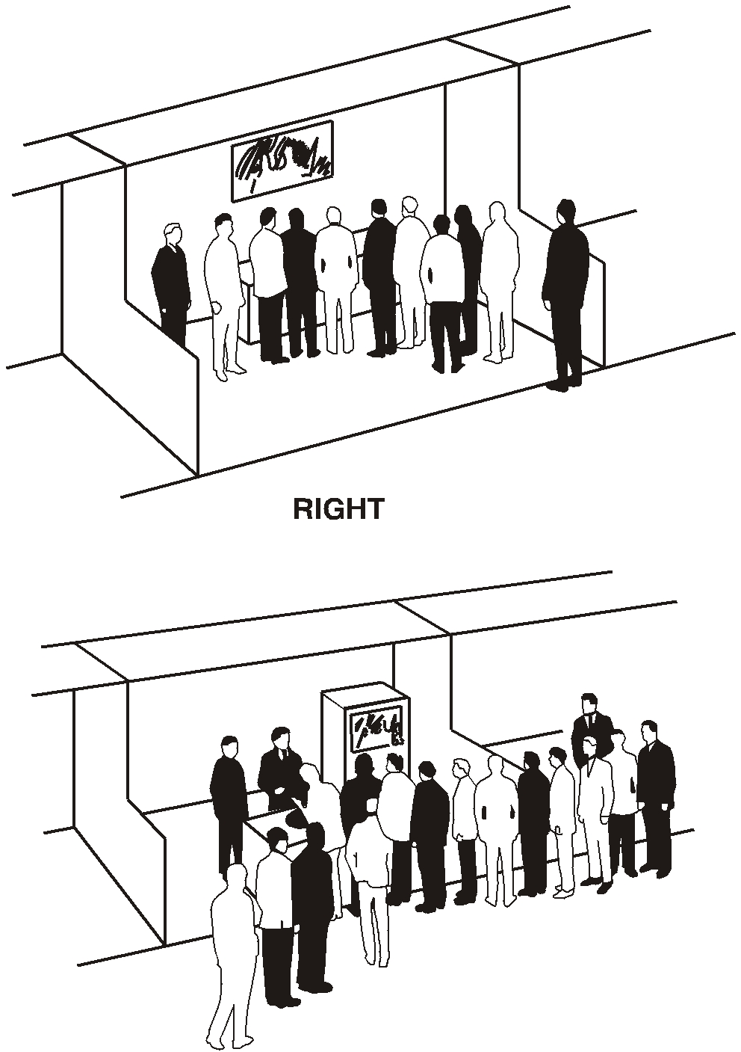
Regulation
Demonstration areas must be organized within the exhibitor’s space so as not to interfere with any traffic aisle and sampling or demonstration tables must be placed a minimum of 2'0" (60cm) from the aisle line. Should spectators or samplers interfere with the normal traffic flow in the aisle or overflow into neighboring exhibits, exposition management will have no alternative but to request that the presentation or sampling be eliminated.
Intent

The aisles are the property of the entire show and each exhibitor has the responsibility to assure proper flow of traffic through the entire show. When large crowds gather to watch a demonstration or for sampling and interfere with the flow of traffic down aisles or create excessive crowds in neighboring booths, it is an infringement on the rights of other exhibitors. Aisles must not be obstructed at any time.

Sound

Exhibitors must police their own booths to be sure the noise levels from demonstrations or sound systems is kept to a minimum and does not interfere with others. Remember the use of sound systems or equipment producing sound is an exception to the rule, not a right. Exposition management reserves the right to determine at what point sound constitutes interference with other and must be discontinued.

WRONG

Safety Precautions
All product demonstrations involving any moving and potentially hazardous machines, displays or parts, must have hazard barriers to prevent accidental injury to spectators. Demonstrations must always be supervised by exhibitor, personnel who can stop the demonstration in the event of an emergency and all demonstrations involving potentially hazardous by-products, such as dust, fumes, sparks or flames ,must be approved in writing by exposition management 60 days prior to the show.

ALL MACHINERY MUST BE PLACED 2 FT. FROM AISLE
UNACCEPTABLE
ACCEPTABLE

J. POSITIONING & OPERATION OF MACHINERY

The display, operation and demonstrator/operator must be within the confines of the booth at all times. No part of the exhibit may extend into the aisle and no booth personnel may be stationed in the aisle, even temporarily.
A situation where an operator must stand in the aisle to start or demonstrate a machine is unacceptable. The operator must be able to start and demonstrate the machine from within the confines of the allotted booth space at all times.

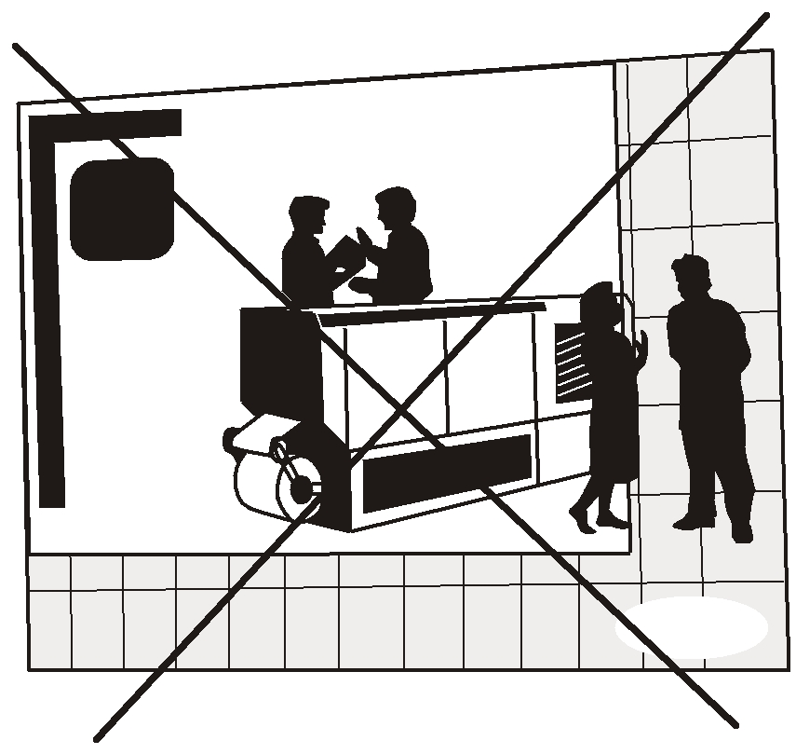
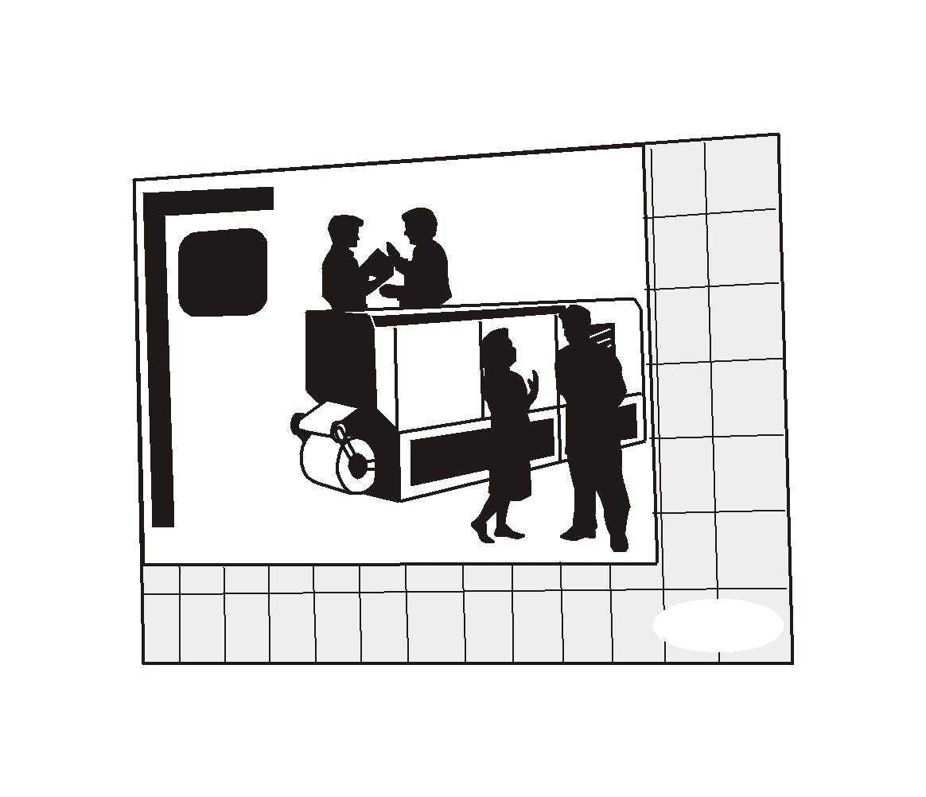

ALL MACHINERY AND
BOOTH PERSONNEL
MUST REMAIN WITHIN THE CONFINES OF THE
BOOTH AT ALL TIMES.

ALL MACHINERY MUST BE PLACED 2 FT. FROM AISLE

